**Lab Manual of Computer Networking**



**Name: Basit Ali**

**Registration No: S23BSCS012**

**Submitted to: Sir Wazir Afrasiab**

**Course: Computer Networking**

**Degree: BSCS**

**Semester: 5th**

**Section: ‘A’**

**Lab-1:**

Q: What is Cisco software and how to install it, attach picture of installation step by step?

A: Cisco is a software containing computing devices to illustrate networking that how nodes are communicate visually.

Picture:

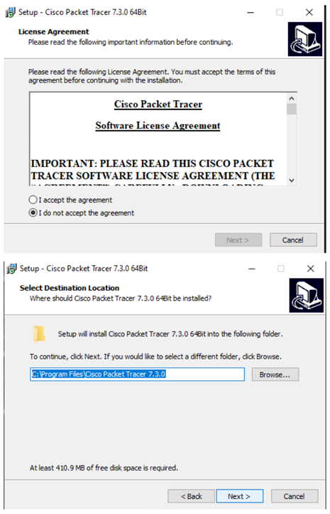

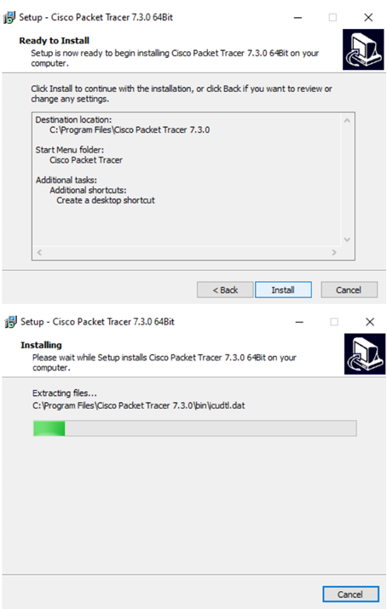

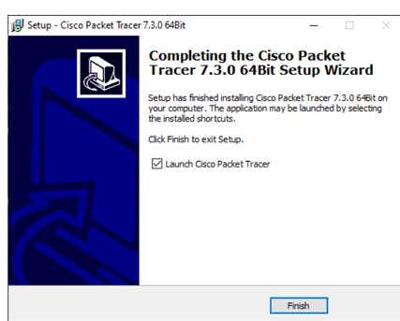

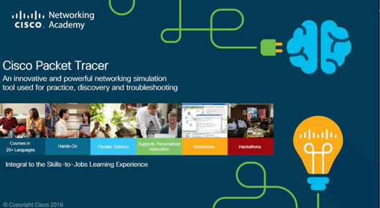

**Lab-2:**

Q: Take two nodes and connect them with straight cable. After it, assign internet protocol (IP) and send data from one node to another node by using ping command?

A: In the above question, directly or indirectly say to make peer-to-peer (P2P) connection.

Picture of P2P:

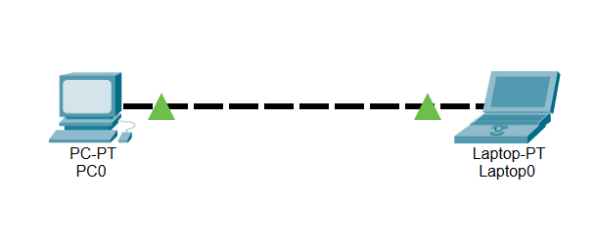

Picture of IP Assign:

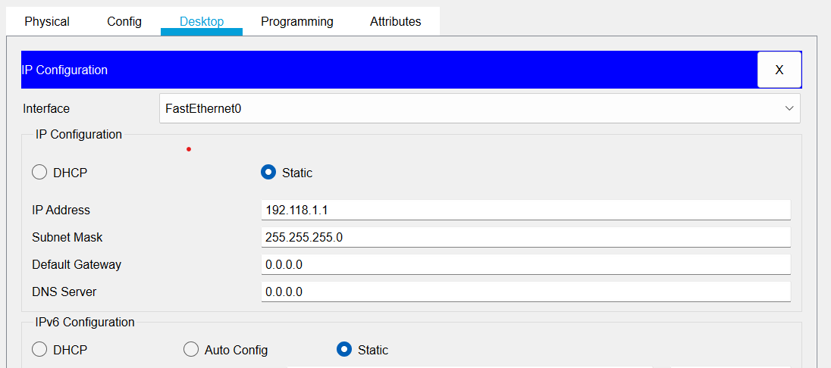

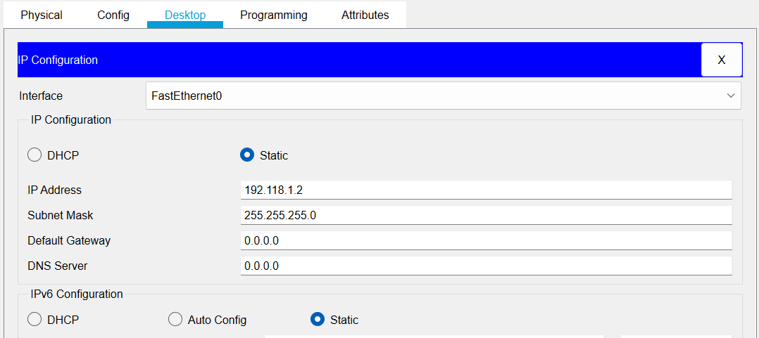

Explanation about above Design:

In above design, I have connected tow nodes with straight cable. After cabling I have assign IP for both nodes of class C manually.

Output of above Design:

